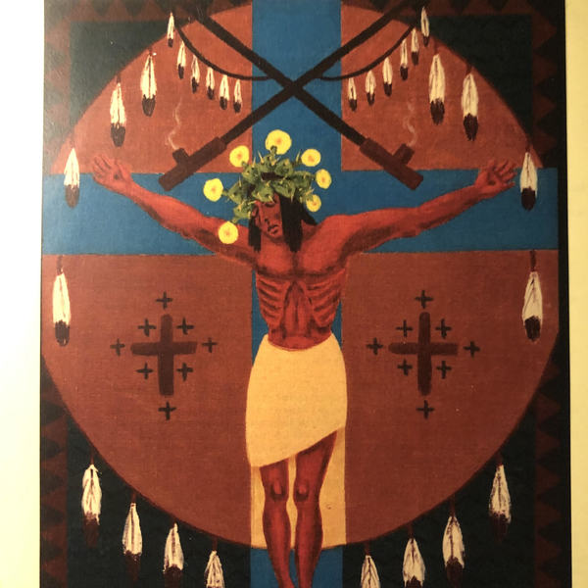
Peniel
"Where Jacob Wrestled With God. ."
Newsletter of Temenos Catholic Worker
P.O. Box 642656
San Francisco, CA 94164
www.temenos.org
Paypal on Website
----------------------
Journal of An Alien Street Priest

The Haunting

Haunting. . .is the relentless remembering and reminding that will not be appeased by settler society's assurances of innocence and reconciliation. Haunting is both acute and general, individuals are haunted, but so are societies. The United States is permanently haunted by the slavery, genocide, and violence entwined in its first, present, and future days . . .Haunting aims to wrong the wrongs, a confrontation that settler horror hopes to evade. (Eve Tuck and C. Ree)

Luke 9"1-6 Tree of Life Version
Sending Out the Twelve
1Now when Yeshua called the twelve together, He gave them power and authority over all the demons and to heal diseases.
2He sent them out to proclaim the kingdom of God and to heal.
3And He said to them, “Take nothing for the journey—no walking stick, no travel bag, no bread, no money, nor even to have two shirts.
4Whatever house you enter, stay there and depart from there.
5And whoever does not receive you, when you leave that town, shake off the dust from your feet as a witness against them.”
6So they went out and began traveling throughout the villages, proclaiming the Good News and healing everywhere.

--------------------------------
Thin places are the times within our lives when we are broken open through tragedy and suffering, where God enters into our vulnerability and guides us into transformation. These are the places where God is most real.

In the past two and a half years my heart has been broken open through walking in the thin places, and my life has been haunted:

Holding the hands of people dying from the coronavirus;

Witnessing a suicide of a teen on zoom;

Haunted by the realization of all of our responsibility in the oppression of minorities--Blacks, Native Americans, homeless, Asian Americans, queer;

I ran away from the south, and my family because of the racism, and prejudice towards blacks; only to find it present in the North; I came west to find Native Americans in particular and others afflicted, And I am haunted by my own white privilege;

On Ash Wednesday as I will move among people living on the street administering ashes, I will be reminded of the pain the Church has caused through homophobia, sexual abuse, and simply ignoring homeless individuals. There will be anger, physical threats, and being spat upon; I am haunted by the pain the Church has inflicted and continues to inflict;

Walking by Mission Delores, I am haunted by the history that has been whitewashed concerning the treatment of Native Americans. The Franciscan Missions enslaved and destroyed Native American populations, a haunting that continues to brutalize and continues to be whitewashed.

I am haunted by the ghosts that are all around, and the brokenness of our hearts and division of our nation are signs of that illness.

One of the ways to begin healing our hauntedness is to avoid inflicting oppression and begin to move into a new way of living and recognize the pain we have inflicted and continue to inflict is to practice the ethos of hospitality that Jesus presents in Luke 9:1-6 (above). Simply to give without expecting anything in return, to move along when asked, and to treat people equally.

We are called to walk with others as our peers. Our hauntedness can lead us into new beginnings, new life! Deo Gratias! Thanks be to God!

Fr. River Damien Sims, sfw, D.Min. D.S.T.
-------------------------------
A Special Thanks To My Friends Who Have Walked with me the Past Month Providing Food, Emotional and Medial Support In My Illness With the Coronavirus: Matthew Laskey and his mom Doreen, Matthew Frederick, Bill, and Dina Tiedge, Dr. Cynthia Geppert, Dr. Karen Cardon, Kaiser Hospital, and the Ensemble Study of Stanford University.
--------------------------------------------------
We Are Beggars: We are purchasing food, socks, KN95 masks, and all of our other essentials for daily living. Give as the Spirit speaks to your heart.

You may give online, PayPal or mail directly to:
Temenos Catholic Worker
P.O. Box 642656
San Francisco, CA 94164
www.temenos.org
-------------------------
